Date: 3 November 2014

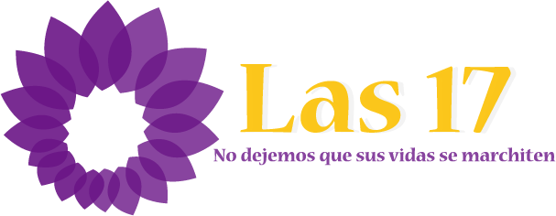

To the members of the Salvadoran Supreme Court of Justice,

On 1 April 2014, human rights advocacy organizations presented 17 requests for pardons to the Legislative Assembly in El Salvador, one for each of the 17 Salvadoran women imprisoned on suspicion of having an abortion and convicted in extremely unfair circumstances. "Las 17" are 17 women living in poverty who had out-of-hospital births or experienced obstetric complications at some point during their pregnancy, and did not have access to (proper) healthcare. These women, profusely bleeding and in danger of losing their lives, sought help at public health facilities, where they were accused of having undergone an abortion, and in the context of El Salvador’s complete ban on abortion, were immediately handed over to local authorities. In the criminal process, moreover, they were charged and convicted for aggravated murder, and received grossly disproportionate sentences ranging from 30 to 40 years in prison, even though prosecutors were unable to provide any evidence demonstrating that these women had committed any misconduct, or that they were responsible for their miscarriages or stillbirths.

All of these women, who accessed health services as a result of a serious threat to their health, were presumed guilty rather than innocent, were refused a standard of reasonable doubt, and were denied their rights to due process, while also receiving little to no proper legal assistance, with in most cases a flawed and apathetic defense. As such, the treatment of Las 17 represents a grave case of institutional violence against women, perpetrated by the State.

As advocates committed to human rights and social justice, we support national civil society efforts to counter the injustice experienced by Las 17 through the submission of the aforementioned 17 pardon requests, noting that by granting clemency, the Salvadoran State can begin to address the mistakes and rights violations against these wrongfully imprisoned ​​women.

In this regard, we stand in solidarity with the unfairly convicted Las 17, and the civil society organizations advocating on their behalf. In keeping with the Salvadoran Special Law for Appeals of Grace, the Constitution of the Republic of El Salvador, and regional and international human rights treaties such as the Convention of Belém do Pará, we appeal to the conscience, compassion, and sense of social justice of the Salvadoran Magistrates and Judges of the Supreme court, to ensure that these 17 women are granted pardons so that they may obtain their freedom, return to their families and resume their lives.

We also call on the Supreme Court to ensure that these cases are resolved as quickly as possible, in compliance with the terms stipulated by law, and with the compassion that these cases deserve.

Signature
Name of the Organisation
Country

